Business Requirements Document

Ryanair website



Grace Keane – G00359990

BSc in Computing in Software Development

Ryanair website based

Features

1. Company logo should be displayed on the left side of the Ryanair website as displayed in figure 1.
2. The company logo should contain a link to the home page. This should navigate to the home page wherever the user is in the site.

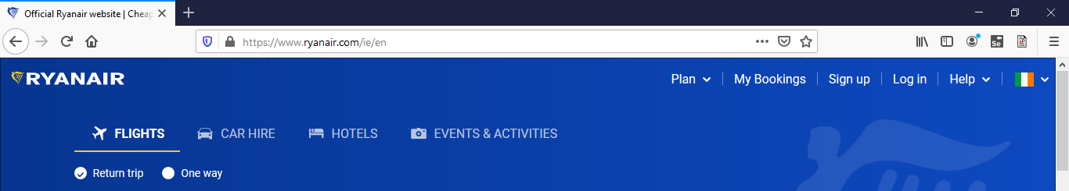

Figure 1

1. The menu, as displayed in figure 2, should be displayed in the top right-hand side of the screen.

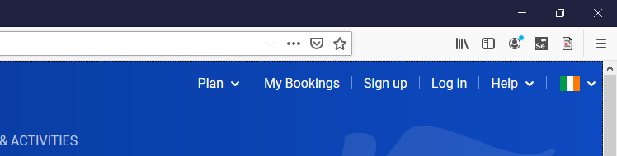

Figure 2

1. The flag icon on the right-hand side of figure 3 should allow you to select the language Ryanair displays. When clicked a drop-down section should appear to allow a user to select a language and change the language that the Ryanair website is written in.

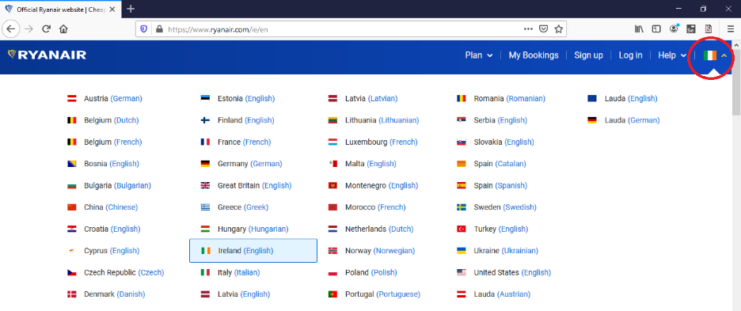

Figure 3

1. A search bar should be in the centre of the screen as displayed in figure 4, the following rules apply to its functionality.
2. From destination as displayed in figure 5.
3. To destination as displayed in figure 6.
4. Depart date as seen in figure 7.
5. Return date as seen in figure 8.
6. Number of people travelling as displayed in figure 9.
7. An option to choose a one-way ticket or a return ticket should be available above the search bar as displayed in figure 4.
8. A search button should be located on the right-hand side of the search bar and allows customers to search for flights, as shown in figure 4.

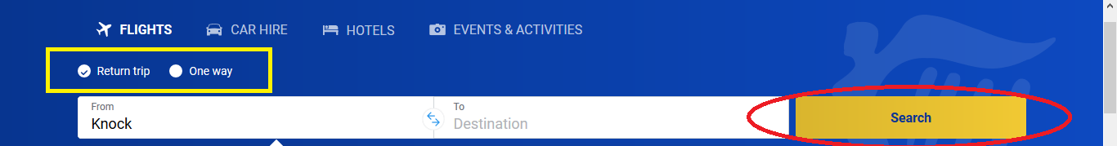

Figure 4

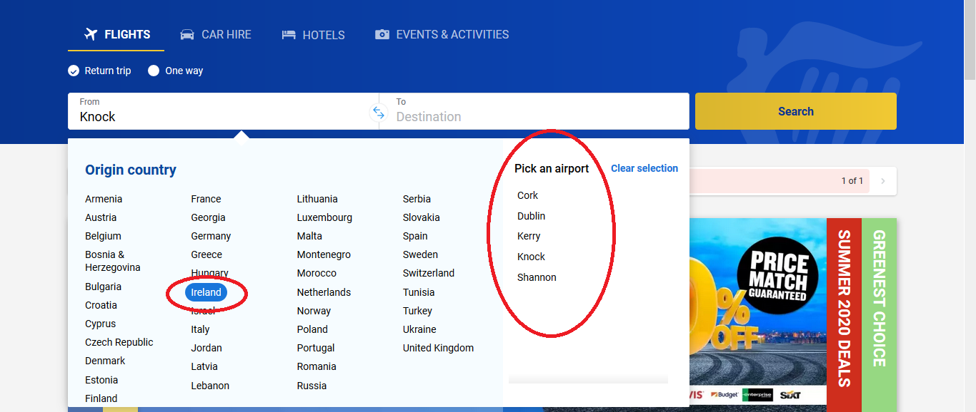

Figure 5

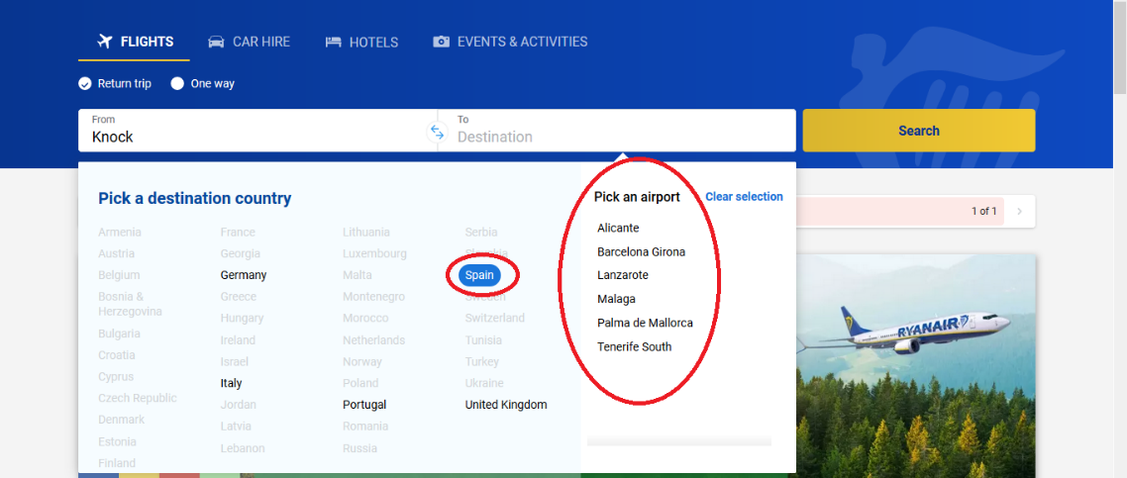

Figure 6

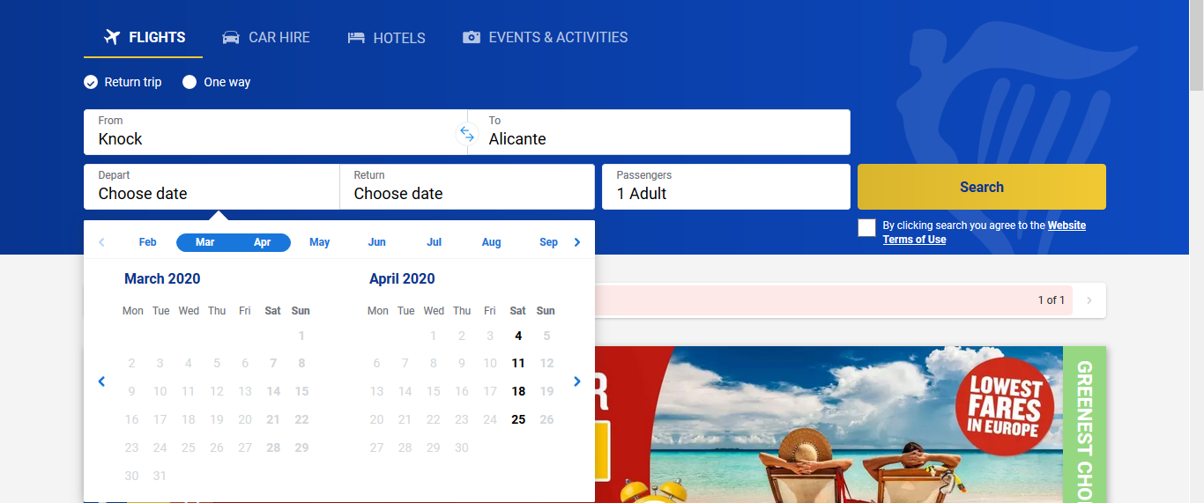

Figure 7

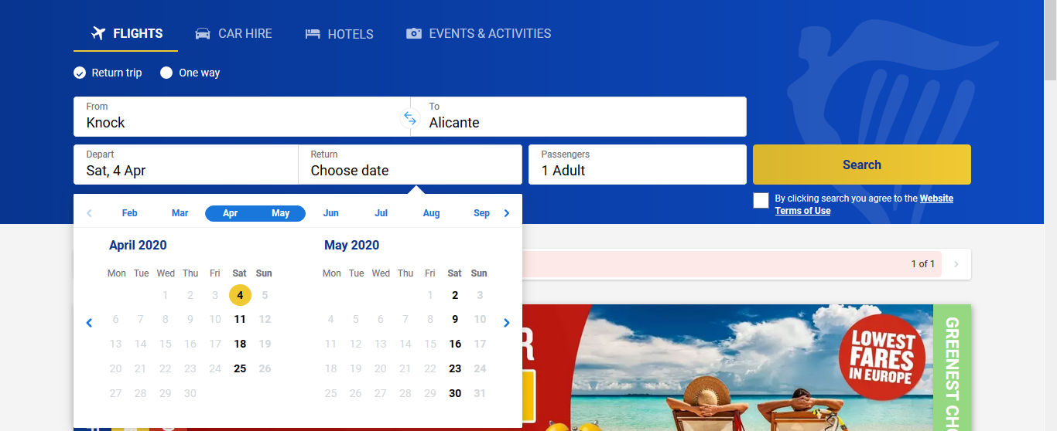

Figure 8

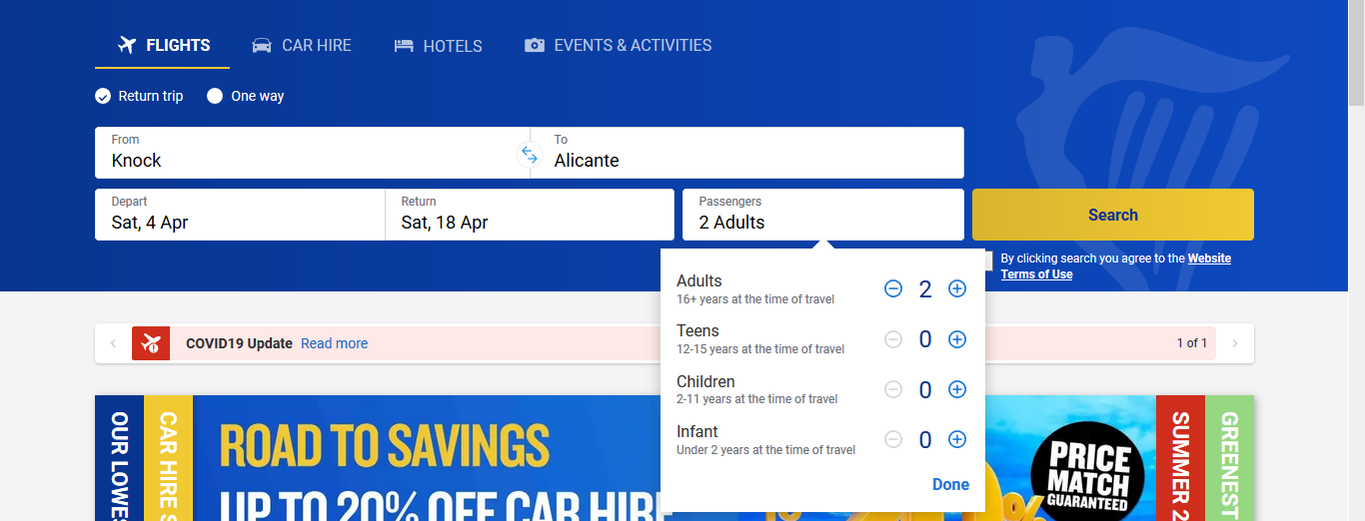

Figure 9

1. The log in link should be in the right side of the Ryanair site as displayed in figure 10. The log in should bring you to a window, the following rules apply to its functionality.
2. An option to log in with email and password,
3. An option to log in with Facebook,
4. An option to log in using Google.

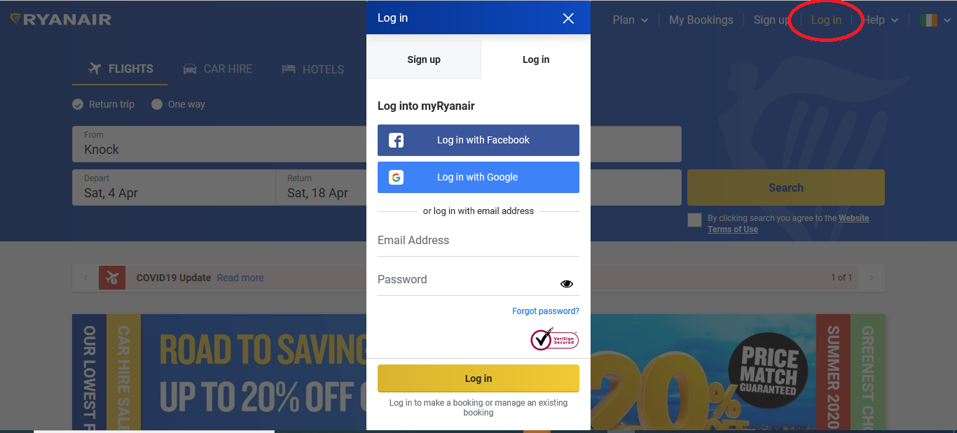

Figure 10

1. The total cost of the flight should be displayed in the top right-hand corner of the Ryanair site as displayed in figure 11.

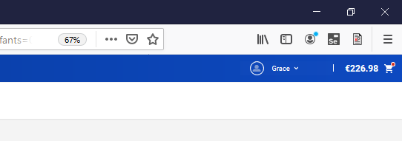

Figure 11

1. The fare type option should be displayed under the travel information as displayed in figure 12. Customers can select either a value fair, regular fair, plus fair or a flexi Plus fair.

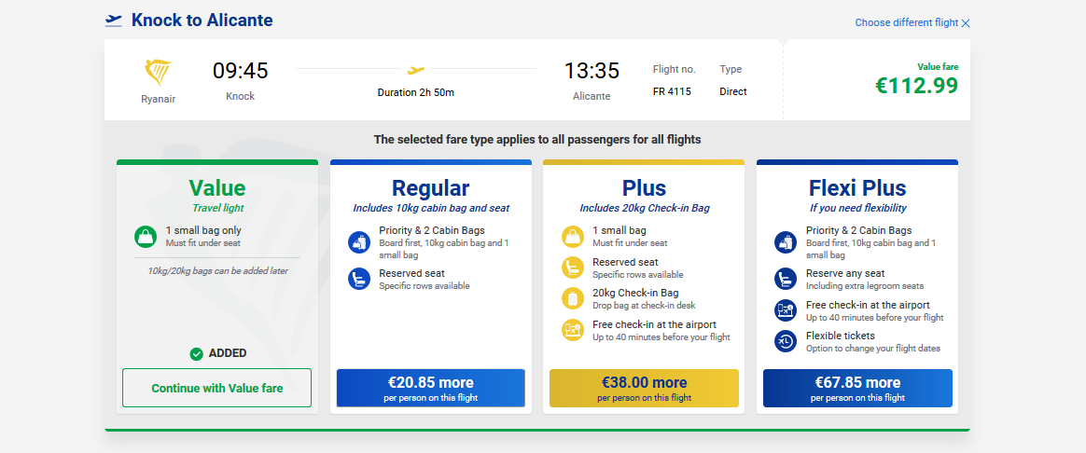

Figure 12

1. Once the fair type has been selected for both journeys a passenger table should appear as shown in figure 13, the following rules apply to its functionality.
2. Title e.g. Mrs, Ms, Mr
3. First name
4. Last name

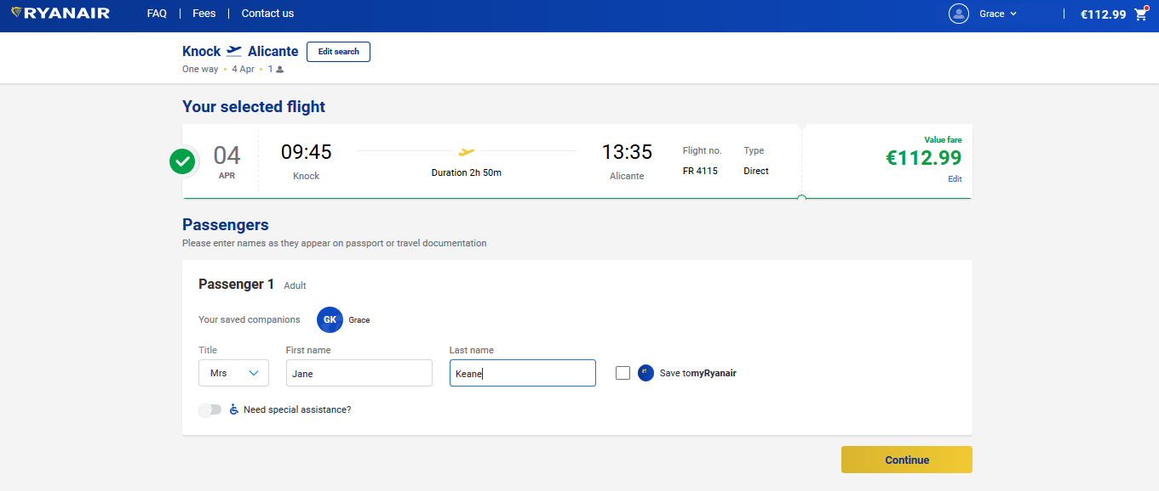

Figure 13

1. A screen should appear to allow customers to pick which seat they would like to book for the flight as shown in figure 14.

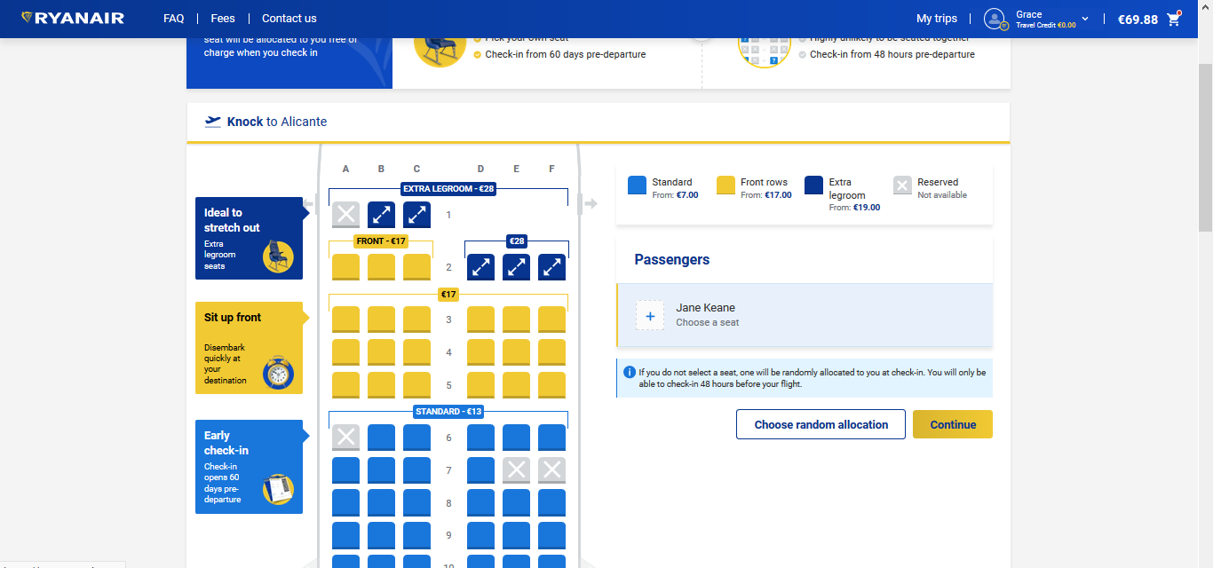

Figure 14

1. The payment screen as displayed in figure 15 should contain a table prompting the user for their credentials such as expiry date, card year, security code, cardholder name, address line 1, address line 2, city and country. It should allow customers to purchase a flight.

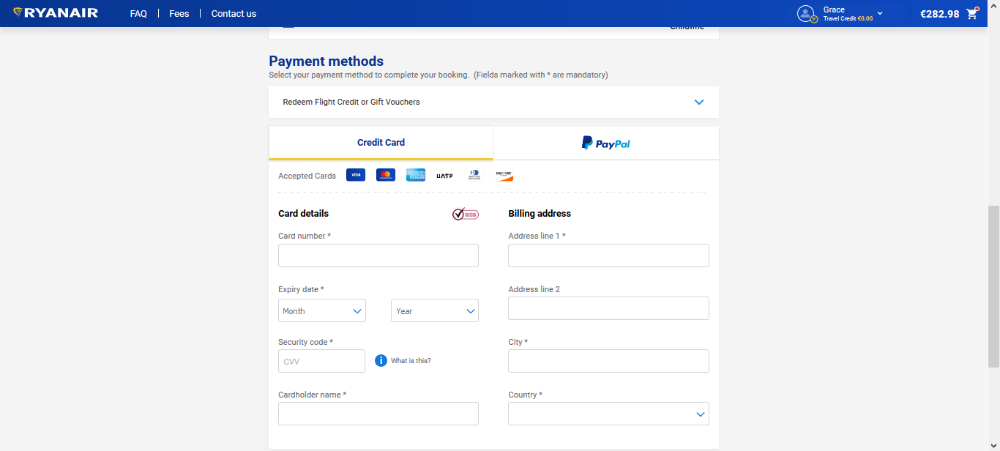

Figure 15

1. The sign in link should be in the right side of the Ryanair site beside the log in link as displayed in figure 16. The sign in should bring you to window, the following rules apply to its functionality.
2. An option to sign in with Facebook,
3. An option to sign in using Google,
4. An option to sign in with their email and password

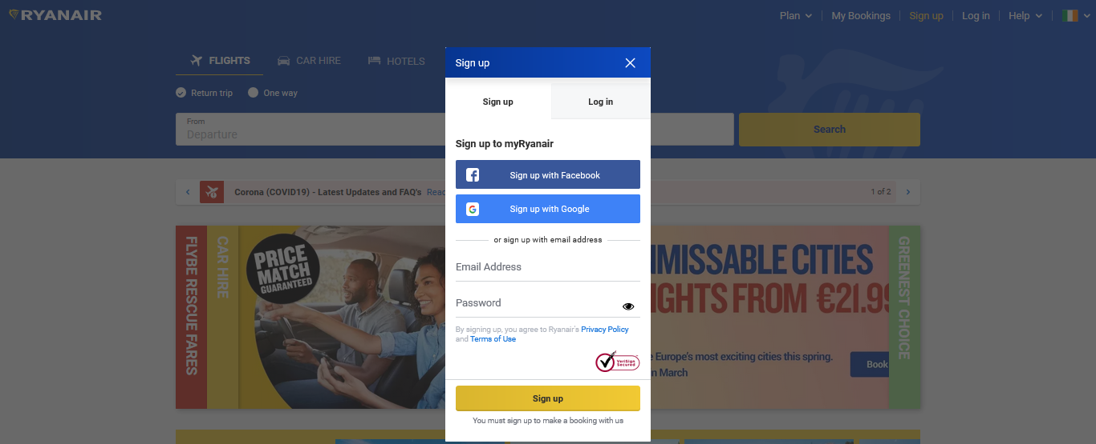

Figure 16